Data Warehouse Schema Diagram
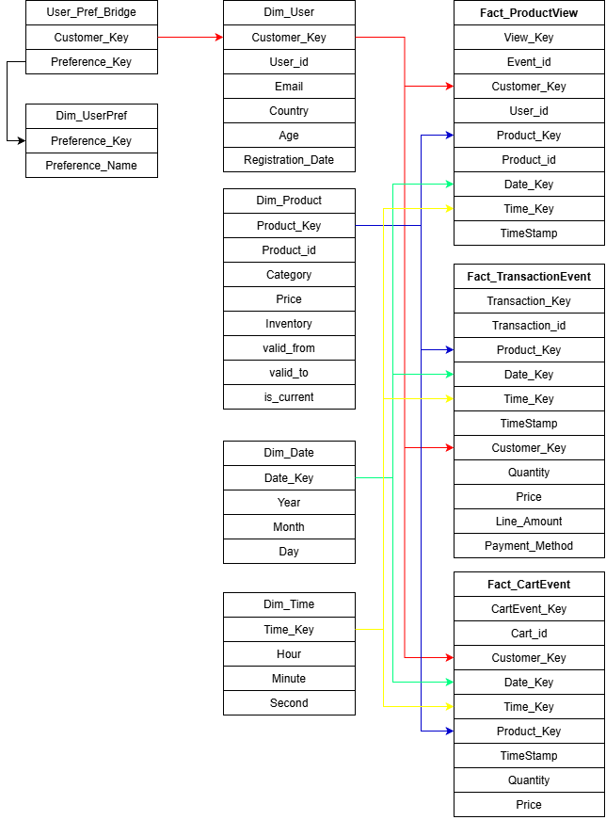
Dimension Tables:
Dim_User
Column Name | Data Type | Description | Key Type / Notes
Customer_Key | SERIAL | Surrogate key for linking users to their preferences | Primary Key
User_ID | VARCHAR(50) | Unique User ID | Natural Key, Unique
Email | VARCHAR(255) | User Email Address | Nullable
Age | INT | User Age | Nullable
Country | VARCHAR(50) | User Country | Nullable
Registration_Date | TIMESTAMP | User Registration Date | Nullable

Keys and Constraints:
PK: Customer_Key
Dim_Product
Column Name | Data Type | Description | Key Type / Notes
Product_Key | SERIAL | Surrogate key for the products to allow for SCD2 | Primary Key
Product_ID | VARCHAR(50) | Unique Product ID | Natural Key, part of uniqueness, not nullable
Category | VARCHAR(50) | Product Category
Price | DOUBLE PRECISION | Product Price
Inventory | INT | Product Inventory
Valid_from | TIMESTAMP | SCD2 Validity Start Datetime | Not Nullable, part of uniqueness
Valid_to | TIMESTAMP | SCD2 Validity End Datetime
Is_Current | BOOLEAN |  | Not Nullable

Keys and Constraints:
PK: Product_Key
Unique (Product_id, valid_from)

Dim_Date
Column Name | Data Type | Description | Key Type / Notes
Date_Key | INT | Primary Key for the Date | Primary Key
Year | INT | Year | Not Nullable
Month | INT | Month | Not Nullable
Day | INT | Day | Not Nullable

Keys and Constraints:
PK: Date_Key
Dim_Time
Column Name | Data Type | Description | Key Type / Notes
Time_Key | INT | Primary Key for the Time | Primary Key
Hour | INT | Hour | Not Nullable
Minute | INT | Minute | Not Nullable
Second | INT | Second | Not Nullable

Keys and Constraints:
PK: Time_Key
Dim_UserPref
Column Name | Data Type | Description | Key Type/ Notes
Preference_Key | SERIAL | Surrogate Primary Key for the preferences | Primary Key
Preference_Name | VARCHAR(100) | The actual preference value | Unique

Keys and Constraints:
PK: Preference_Key
Bridge Tables:
User_Pref_Bridge
Column Name | Data Type | Description | Key Type/ Notes
Customer_Key | INT | Surrogate key of a user from Dim_User | Foreign Key for Dim_User, part of primary key
Preference_Key | INT | Surrogate key of a preference from Dim_UserPref | Foreign Key for Dim_UserPref, part of primary key

Keys and Constraints:
PK: (Customer_Key,Preference_Key)
Fact Tables:
Fact_ProductView (1 view by 1 user on 1 product)
Column Name | Data Type | Description | Key Type/ Notes
View_Key | SERIAL | Surrogate key of a product view | Primary Key
Event_id | VARCHAR(50) | View event natural key | Natural Key, Unique
Customer_Key | INT | Surrogate key of the customer who triggered the view event | Foreign key to Dim_User
User_id | VARCHAR(50) | User id of the user who triggered the event | Not Nullable
Product_Key | INT | Surrogate key of the product the view event was triggered on | Foreign key to Dim_Product
Product_Id | VARCHAR(50) | Product id of the product the view event was triggered on | Not Nullable
Date_Key | INT | Foreign key to the date table | Foreign key to Dim_Date
Time_Key | INT | Foreign key to the time table | Foreign key to Dim_Time
Timestamp | TIMESTAMP | Time of the event | Not Nullable

Keys and Constraints:
PK: View_Key
Fact_TransactionEvent (1 transaction by 1 user on 1 product)
Column Name | Data Type | Description | Key Type/ Notes
Transaction_Key | SERIAL | Surrogate key of the transaction | Primary key
Transaction_id | VARCHAR(50) | Natural key of the transactions | Natural Key
Customer_Key | INT | Surrogate key of the user from Dim_User | Foreign Key for Dim_User
Product_ Key | INT | Surrogate key of a preference from Dim_Product | Foreign Key for Dim_Product
Date_Key | INT | Foreign key to the date table | Foreign key to Dim_Date
Time_Key | INT | Foreign key to the time table | Foreign key to Dim_Time
Timestamp | TIMESTAMP | Time of the event | Not Nullable
Quantity | INT | Quantity of the product bought
Line_Amount | DOUBLE PRECISION | Total price of the product after accounting for quantity
Payment Method | VARCHAR(50) | Payment method
Price | DOUBLE PRECISION | Price per product

Keys and Constraints:
PK: Transaction_Key
Unique (transaction_id, product_key)

Fact_CartEvent
Column Name | Data Type | Description | Key Type/ Notes
CartEvent_Key | SERIAL | Surrogate key of the cart | Primary key
Cart_id | VARCHAR(50) | Natural key of the cart | Natural Key
Customer_Key | INT | Surrogate key of the user from Dim_User | Foreign Key for Dim_User
Product_ Key | INT | Surrogate key of a preference from Dim_Product | Foreign Key for Dim_Product
Date_Key | INT | Foreign key to the date table | Foreign key to Dim_Date
Time_Key | INT | Foreign key to the time table | Foreign key to Dim_Time
Timestamp | TIMESTAMP | Time of the event | Not Nullable
Quantity | INT | Quantity of the product placed in cart
Price | DOUBLE PRECISION | Price of the product placed in the cart

Keys and Constraints:
PK: CartEvent_Key
Unique (cart_id, product_key)

